DIGITAL CLOCK

Project subm itted to the

SRM University – AP, Andhra Pradesh

for the partial fulfillment of the requirements to award the degree of

**Bachelor of Technology/Master of Technology**

In

**Computer Science and Engineering**

**School of Engineering and Sciences**

Submitted by

**BHAVYA SREE**

**(AP21110010184)**

Under the Guidance of

**(POONAM YADAV)**

**SRM University–AP**

**Neerukonda, Mangalagiri, Guntur**

**Andhra Pradesh – 522 240**

**[DECEMBER, 2022]**

**Certificate**

Date: 16-Nov-22

This is to certify that the work present in this Project entitled “**DIGITAL CLOCK**” has been carried out by **BHAVYA SREE[GROUP-16]** under my/our supervision. The work is genuine, original, and suitable for submission to the SRM University – AP for the award of Bachelor of Technology/Master of Technology in **School of Engineering and Sciences**.

**Supervisor**

(Signature)

Dr. /Prof. **POONAM YADAV**

# Acknowledgements

I started this project as part of my course curriculum .It gives us great pleasure to present the report of this place of this project work conducted towards the fulfillment of the project **“DIGITAL CLOCK”.**

I take this opportunity to thank those who have made the efforts in success of this project.I external my special gratitude towards **Prof. POONAMYADAV**.who has been a constant source of motivation,encouragement ,and guidance that has gone a long way in helping the completion of this project .I express my warm wishes to the entire staff members for their assistance and kind guidances who helped me out of all my quries

I also heartily thankful to all my friends for providing me all the useful requrirement that we needed by me for completion of project

GROUP-16

CSE-C

This project is to help us with the understanding of the

Python Programming and how we can we use python to

create a Program with GUI , Which Is not Hard to

Understand

# 

# Table of Contents

[Certificate---------------------------------------------------------------------------------3](https://docs.google.com/document/d/13F_dHejAok0h_xNOa9VluiItWVhpU2Vp1S2EgRqj2NI/edit#heading=h.gjdgxs)

[Acknowledgements](https://docs.google.com/document/d/13F_dHejAok0h_xNOa9VluiItWVhpU2Vp1S2EgRqj2NI/edit#heading=h.30j0zll) -------------------------------------------------------------------5

[Table of Contents](https://docs.google.com/document/d/13F_dHejAok0h_xNOa9VluiItWVhpU2Vp1S2EgRqj2NI/edit#heading=h.1fob9te) -------------------------------------------------------------------7

[Abstract](https://docs.google.com/document/d/13F_dHejAok0h_xNOa9VluiItWVhpU2Vp1S2EgRqj2NI/edit#heading=h.3znysh7) ----------------------------------------------------------------------------9

[Statement of Contributions](https://docs.google.com/document/d/13F_dHejAok0h_xNOa9VluiItWVhpU2Vp1S2EgRqj2NI/edit#heading=h.tyjcwt) ---------------------------------------------------------11

1.[Introduction--------------------------------------------------------------------------13](https://docs.google.com/document/d/13F_dHejAok0h_xNOa9VluiItWVhpU2Vp1S2EgRqj2NI/edit#heading=h.17dp8vu)

2.[Methodology-------------------------------------------------------------------------15](https://docs.google.com/document/d/13F_dHejAok0h_xNOa9VluiItWVhpU2Vp1S2EgRqj2NI/edit#heading=h.lnxbz9)

[2.1 Design----------------------------------------------------------------------------15](https://docs.google.com/document/d/13F_dHejAok0h_xNOa9VluiItWVhpU2Vp1S2EgRqj2NI/edit#heading=h.35nkun2)

2.2Implementation-----------------------------------------------------------------17

2.2.1 Code------------------------------------------------------------------------17

2.2.2 Explanation of code-----------------------------------------------------17

3.Results---------------------------------------------------------------------------------18

4.[Conclusion-----------------------------------------------------------------------------20](https://docs.google.com/document/d/13F_dHejAok0h_xNOa9VluiItWVhpU2Vp1S2EgRqj2NI/edit#heading=h.2jxsxqh)

**Abstract**

A digital clock is a type of clock that display the time digitally.now a days digital clocks are using more because digital clocks can be very small.A DIGITAL CLOCK is a software program that display time and data .user can enter blackground colour and front colour as user wishes .It is a 12 hours clock.This GUI based Digital clock is the most basic method for displaying time and date .

**Statement of Contributions**

**Idea,Implementation:**

--- Bodapati Bhavya Sree(AP21110010184)

**Introduction**

The great part of creating your own graphical user interface (GUI) apps is that you can customized them however you want .From text front to background colour,all features are available for customized.

In this project we are going to created a digital clock using Tkinter Library In the python programming .

In this section,I will show you how to create a digital clock.This is a simple task to get started with Tkinter library in python,which is a built-in package that comes with python .Tkinter has some cool features that can be used to bulid simple app

Python Programming and how we can we use python to

create a Program with GUI , Which Is not Hard to

Understand

**2.** [**Methodology**](https://docs.google.com/document/d/13F_dHejAok0h_xNOa9VluiItWVhpU2Vp1S2EgRqj2NI/edit#heading=h.lnxbz9)

**2.1 DESIGN:**

We will be using the tkinter module and time and date module to build digital clock.

* **Tkinter Module**

Tkinter is the standard GUI library for Python. Tkinter gets its name from Tk interface. When python is combined with Tkinter it provides a fast and easy way to create GUI applications.

* **TIME AND DATE MODULE**

Time module provides a variety of ways of getting time, we are going to use strftime() to parse the current time and date. Hour: Minutes: Seconds format for time.year/Month/date format for date .

* **Implementing the digital clock**

In this code, we will use mainloop() to prevent the displayable window from exiting quickly.

**2.1.1Implementation**

**2.2.1 CODE**

"""Code For Digtal Clock with GUI with TKinter"""

# importing whole module

import time

from tkinter import *

# creating tkinter window

root = Tk()

root.title("Digital Clock")

root.resizable()

lbl = Label(root)

lbl.grid(row=0, column=0)

# This function is used to

# display time on the label

def display():

    time_get = time.strftime("%Y/%m/%d\n%I:%M:%S %p")

    lbl.config(text=time_get, bg='black', fg='white',

               font=('Times New Roman', 50, 'bold'))

    lbl.after(100, display)

display()

root.mainloop()

**2.2.2 Explanation of code:**

Now let’s see how to create a digital clock GUI application with python.

I will first start with importing the libraries:

# importing whole module

import time

from tkinter import *

These Modules are used to import the Tkinter library to use its modules in the code .

Now let’s define creating Tkinter window.

# creating tkinter window

root = Tk()

root.title("Digital Clock")

resizable() - Is used to allow Tkinter root window to change it’s size according to the the users need as well we can prohibit resizing of the Tkinter window.

root.resizable()

lbl = Label(root)

Now here I will define the front of the time and it’s colour,and Background colour of the digital .

# This function is used to

# display time on the label

def display():

    time_get = time.strftime("%Y/%m/%d\n%I:%M:%S %p")

    lbl.config(text=time_get, bg='black', fg='white',

               font=('Times New Roman', 50, 'bold'))

    lbl.after(100, display)

This module is used for display().

Now let’s define the main function of our digital clock.

lbl.after(100, display)

display()

root.mainloop()

**3.Results**

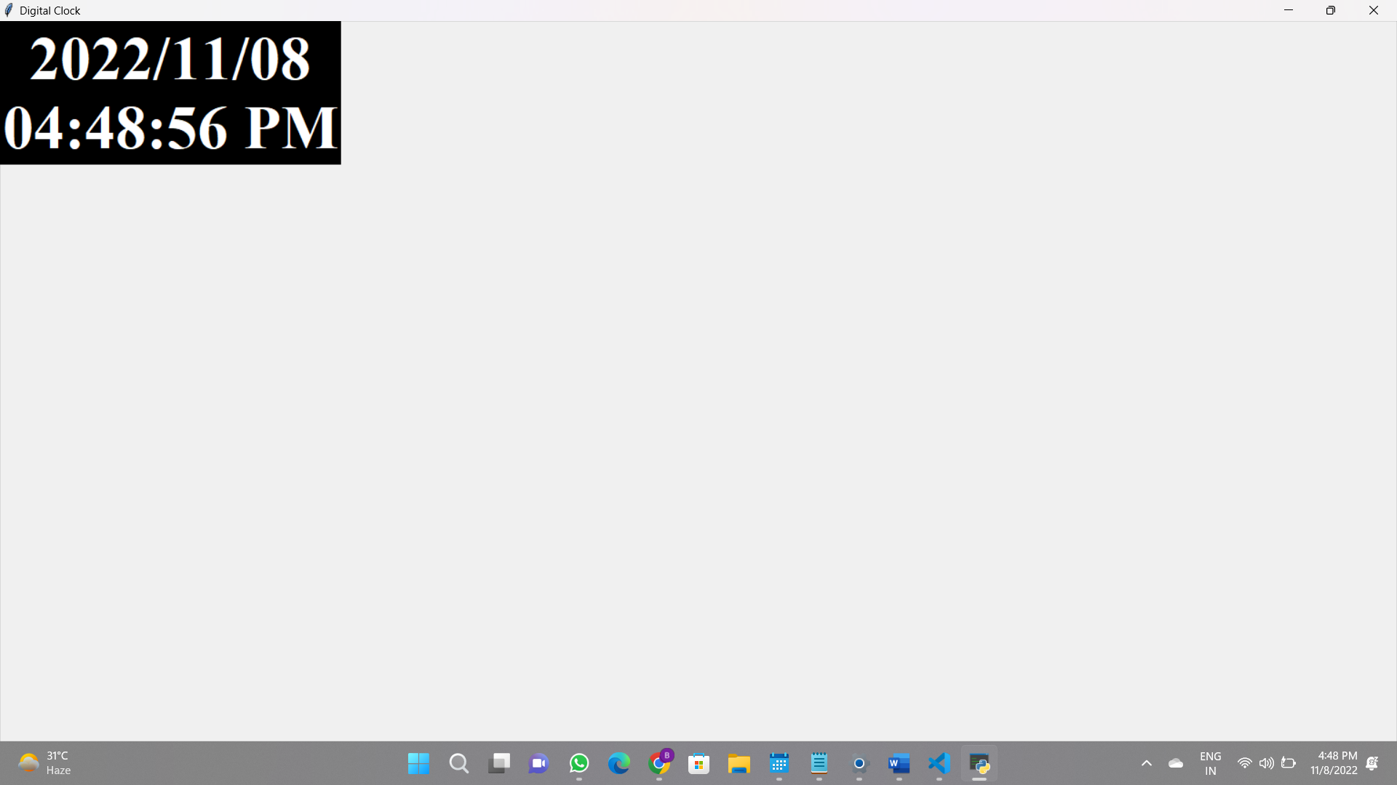

**4.Conclusion**

Here we are completed with our GUI using python Tkinter.with above steps we successfully created an digital clockproject using python.in this process of making this project ,we have understand the concepts and how implement them.